**Tracking Soil Nitrogen Loss and Availability**

**Report for Year 2 (2016), Project 802 NREC 2015-02615, February 2017**

Emerson Nafziger and Cameron Pittelkow, Crop Sciences, Junming Wang, Illinois State Water Survey, and Dan Schaefer, IFCA

This project was initiated to use soil N data gathered under the N-Watch program and to generate new data on soil N trends following application of different forms and times of N application in small-plot trials at research centers and on farmer fields.

**2016 N Tracking Results**

As in 2015, we were again provided in 2016 some of the 2016 N-Watch soil N data gathered under that program from producer fields, mostly in central Illinois. These were identified only by GPS coordinates. The data were used to initiate setting up retrieval of soil and weather information by site. The data are to be used to calibrate the soil N model.

The planned N-tracking studies at the four central-northern Illinois Crop Sciences Research & Education Centers were carried out as planned, but with two additional treatments: we applied 200 lb. N per acre 6 ways: as NH3 in the fall (1) with and (2) without N-Serve; as NH3 in the early spring 2 to 3 weeks before planting (3) with and (4) without N-Serve; (5) 100 lb. N as NH3 in the fall with N-Serve + 50 lb. N as UAN at planting + 50 lb. N as UAN at sidedress (V5-V6); and (6) 50 lb. N as UAN at planting + 150 lb. N as UAN at V5-V6 sidedress. Due to an application error, spring NH3 with N-Serve was not applied at DeKalb. These same treatments were applied as part of on-farm N rate trials at 2 sites, one each in McLean and Sangamon Counties.

With both southern Illinois RECs closed, we established trials on farmer fields in Cumberland (near Neoga) and Williamson (near Marion) Counties with only four treatments sampled: zero N, 150 lb. N/acre as UAN at planting, and 50 lb. N at planting followed by 100 lb. N as UAN at V5 or at V9. The trial near Marion was abandoned due to heavy rain after planting and poor stands.

Soil samples were taken from two reps of each N treatment beginning in fall after application, at the time of early spring NH3, then at planting and every 14 days after planting, up to tasseling. Samples taken at 0 to 1 and 1 to 2 ft. depths, and were sent to a commercial soil lab for analysis of NO3 and NH4. Soil N amounts were calculated as lb. N/acre in the top 2 ft., by multiplying average ppm values by 8. Yields were taken by plot combines on the RECs. In 2016 we also took soil samples after harvest to see how much N remained following selected application times and forms: fall NH3 + N-Serve, spring NH3 without N-Serve, 50 lb. at planting followed by 150 lb. at sidedress, and the zero-N check.

**Results**

As shown in the following table, May and June rainfall totals were close to normal in 2016, in contrast with the 2-month totals of 12 to 15 inches at these sites in 2015. Exceptions included a 4-inch rainfall on May 11 at DeKalb, which reduced stands some. June was very dry at Perry (Orr Center) and soils remained relatively dry throughout the 2016 season at that site.

|  |  |  |  |  |  |  |
| --- | --- | --- | --- | --- | --- | --- |
| rainfall | DeKalb | Monmouth | Urbana | Perry |  |  |
| May | 8.07 | 3.83 | 4.70 | 3.49 |  |  |
| June | 3.72 | 4.72 | 5.69 | 0.70 |  |  |

At the DeKalb site, soil N amounts showed pattern similar to what we saw in 2015: levels remain fairly constant through May and then decline as the crop takes up N through June and up to tasseling (Figure 1. Amounts of N recovered at this site were a little lower through May in 2016 compared to 2015, but reached similar levels by tasseling in July. At Monmouth, Amounts of soil N recovered through May were somewhat typical, but we never saw the drop in soil N during June that we have seen in every other site in this study to date (Figure 2). That includes the zero-N control, which has soil N levels above 200 lb./acre in the top 2 ft. at tasseling. The site where we located this trial may have been a feedlot or a place where large amounts of manure were spread prior to 1980. On June 29, samples, from a zero-N check plot in a study in the same field about 100 yards south of this trial had only 68 lb. N in the top 2 ft.; this shows that location within the field was the main factor.

Soil N levels tracked at Urbana in 2016 were in a familiar pattern, but the 50 lb. at planting + 150 lb. at sidedress never showed high levels, probably because the sidedress N was applied after the May 20 sampling and levels by the June 3 sampling were already coming down (Figure 3). At Perry, where soils were somewhat dry much of the season, soil N levels did not drop in June as they normally do; by tasseling time, levels where fertilizer N had been applied remained fairly around 150 lb. per acre (Figure 4). At Neoga, where planting was late, soil N levels rose after planting-time or sidedress application, and followed a familiar pattern (Figure 5).

Among the four REC sites, soil N levels following crop harvest ranged from an average across N treatments of only 60 lb. per acre at DeKalb to 232 lb. at Monmouth (Figure 6). Only at Perry, where soils at the end of the season were very dry, did N treatment make much difference in the amount of residual N: spring-applied ammonia had 173 lb. N per acre while spring-split UAN had only about half that amount. Soil N amounts in the top two feet of soil dropped by similar amounts between tasseling and post-harvest samples, ranging from 24 lb. N per acre at Perry and Urbana to 33 lb. at DeKalb and 36 lb. at Monmouth.

The on-farm sites were sampled slightly less frequently than the on-REC sites, but showed similar trends in soil N through the spring (Figures 7-8). Compared to the on-REC sites, soil N levels did not fall quite as fast or as far during plant uptake at either site, especially following spring-applied NH3 at the Sangamon County site (Figure 7). The 110lb. application in the fall (a treatment we did not have at the REC sites) showed levels above those in the unfertilized check until the crop neared tasseling, when they fell to the levels of the check.

Above-average soil temperatures and a large amount of rainfall in December 2015 raised concerns about conversion of fall-applied ammonia to nitrate and possible loss of nitrate before spring 2016. We found that fall-applied N was in fact mostly nitrate by April, and that using N-Serve did not increase the percentage of ammonium in recovered soil N in the spring (Figure 9). Applying NH3 in the spring effectively lowered the percentage of soil N found as nitrate during May, but using N-Serve with spring-applied NH3 did not appear to slow the conversion to nitrate.

Corn yield was higher with 200 lb. N per acre than without N at all REC sites in 2016, but with the exception of the lower yield with fall NH3 without N-Serve at DeKalb, N form and timing and the use of N-Serve had no effect on yield at any site (Table 1). With soil N in slightly greater abundance from June to tasseling in 2016 compared to 2015, it makes sense that the crop was better-supplied with N in 2016, such that having more soil N following some forms and times did not contribute to yield. DeKalb was the only site to receive heavy rainfall in May 2016, and had N-Serve with fall NH3 kept more of the soil N in ammonium form in May, we might have credited that with the lower yield where N-Serve was not use with fall N. In fact, soil N values were nearly identical in fall NH3 with and without N-Serve, and nitrate was slightly higher where N-Serve had been used (data not shown.)

The yield response to N form and timing was similar to that at the RECs for the Sangamon County site, but not for the McLean County site (Table 2). Variability was high at the Sangamon County site: the fall-planting time-sidedress split application there yielded 46 bushels less than the planting time + sidedress split, but the difference was not statistically significant. At the McLean County site, with very high yields, the fall/spring split (3-time) application yielded the most at 278, followed by spring NH3 with N-Serve at 269 bushels per acre. Spring NH3 without N-Serve yielded only 255, but this was not significantly different that spring NH3 with N-Serve. N-Serve added to fall NH3 application, however, significantly increased yield (by 17 bushels) compared to fall NH3 without N-Serve.

At the Neoga site in southeastern Illinois, the no-N check yielded 141 bushels per acre, and the three treatments sampled – 150 UAN at planting, 50 at planting followed by 100 lb. N at V6 or V9, yielded 186, 179, and 179, respectively; none of the three yielded significantly differently from another.

In 2016 we added to the project sampling corn plants in the zero-N and 200 lb. spring NH3 treatments. We sampled at the same time as for soil N, beginning at about V6 and going through VT. There was a surprisingly large range among plant N content at tasseling – the least amount was 118 lb. N per acre in the plants at Monmouth while at Urbana we found 253 lb. N per acre (Figure 10.) Values at DeKalb (209 lb. N) and at Perry (147 lb. N) were closer to what we might have expected. Based on expected uptake of about 1 lb. N per bushel of yield, N content as tasseling would represent 96, 50, 106, and 75% of total N requirement at DeKalb, Monmouth, Urbana, and Perry, respectively. It’s possible that we did not have large enough plant samples to accurately measure N content, but the wide range of uptake among sites was unexpected, and no good explanation is available for that.

**Summary**

With very different weather conditions in June 2016 compared to a year earlier, this project in 2016 added a great deal to our knowledge of how N behaves in the soil, and how N management might affect the soil supply of N. In 2015 we found soil N to be high at the end of May, then to decline more or less linearly up to tasseling, by which time it was close to background (less than 80 lb. or so of N in the top 2 ft.) levels. In 2016, although soil N levels again declined during the period of plant N uptake, we found considerably higher soil N values at tasseling than we had found in 2015. Yields were not higher in 2016, however, so it appears that having more than 80 to 100 lb. of soil N in the top 2 feet at tasseling is not associated with higher yields. This contradicts the claims of those promoting “late” N application and the idea that soil nitrate needs to be “maintained at 20 ppm in the top 2 feet of soil for the season (after mid-vegetative stages.)” That‘s simply not supported by what we have found, and maintaining such high levels of soil N after pollination will greatly increase the chances of having N left in the soil at maturity, after which it will be free to move to tile lines.

We have also found that applying N in the fall, though it is likely to convert to nitrate by the time the crop starts to take up N the next spring, is not likely to move out of the rooting zone if the weather is not especially wet in May and June.

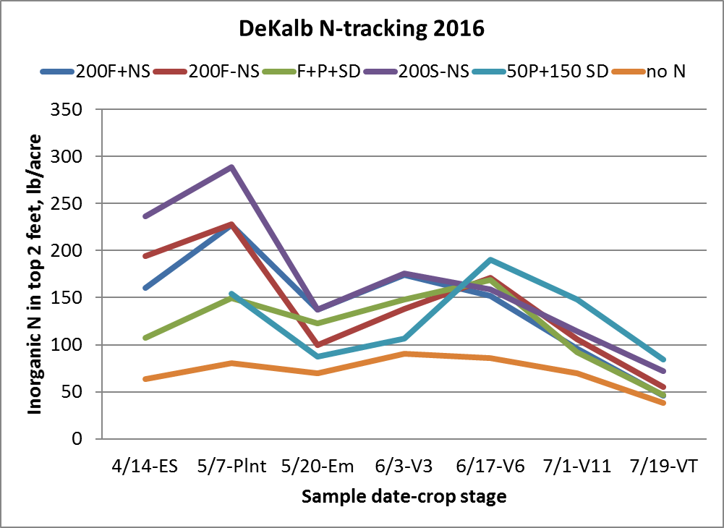

Figure 1. Soil N following application of N at different times and forms, DeKalb, 2016.

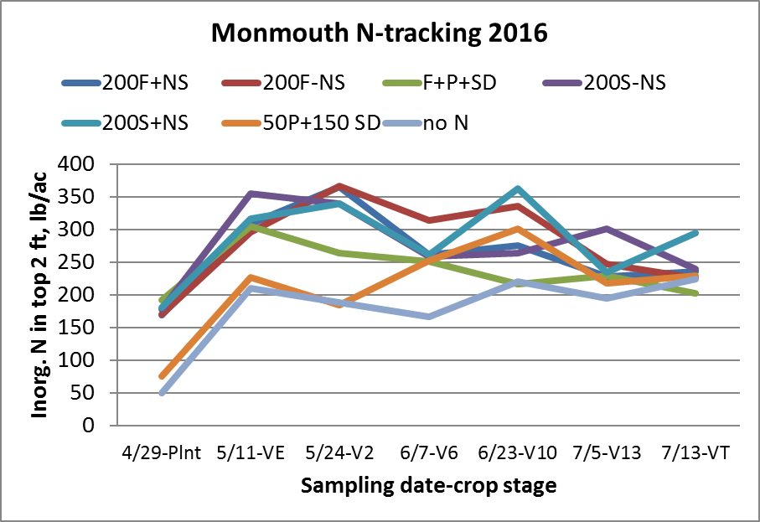

Figure 2. Soil N following application of N at different times and forms, Monmouth, 2016.

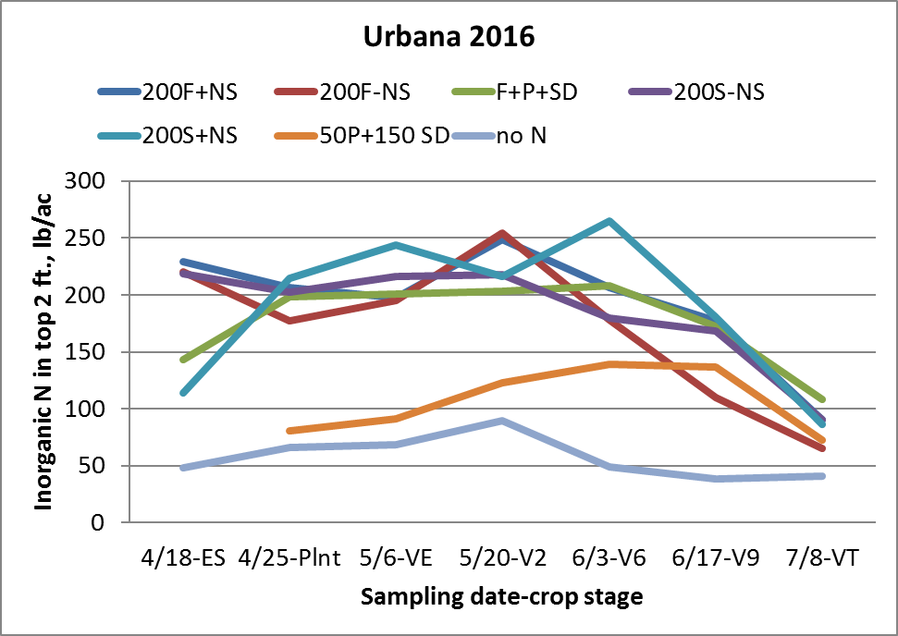

Figure 3. Soil N following application of N at different times and forms, Urbana, 2016.

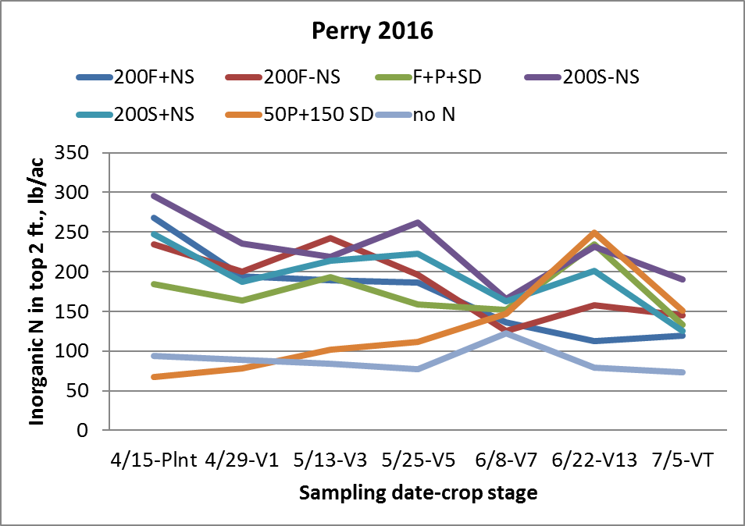

Figure 4. Soil N following application of N at different times and forms, Perry, 2016.

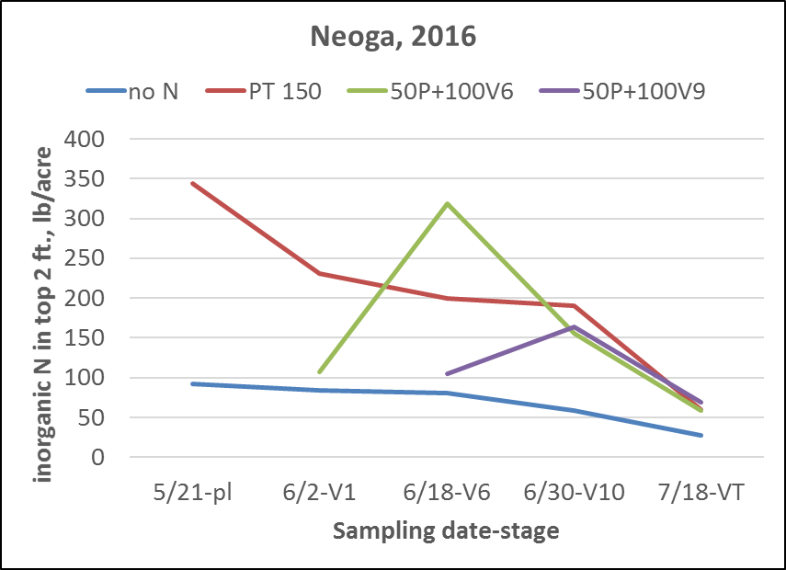

Figure 5. Soil N following application of N at different times and forms, Neoga, 2016.

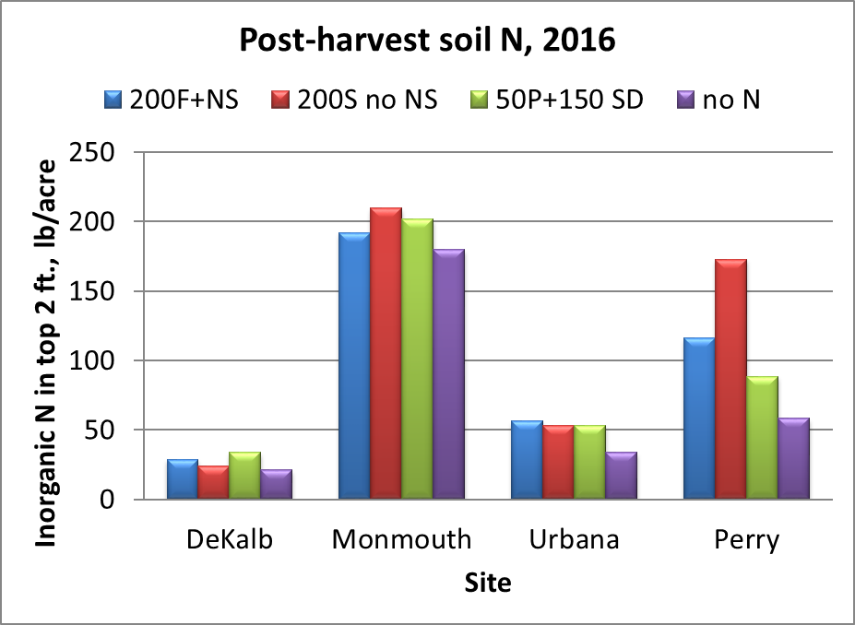

Figure 6. Soil N following application of N at different times and forms at the four research center sites in 2016.

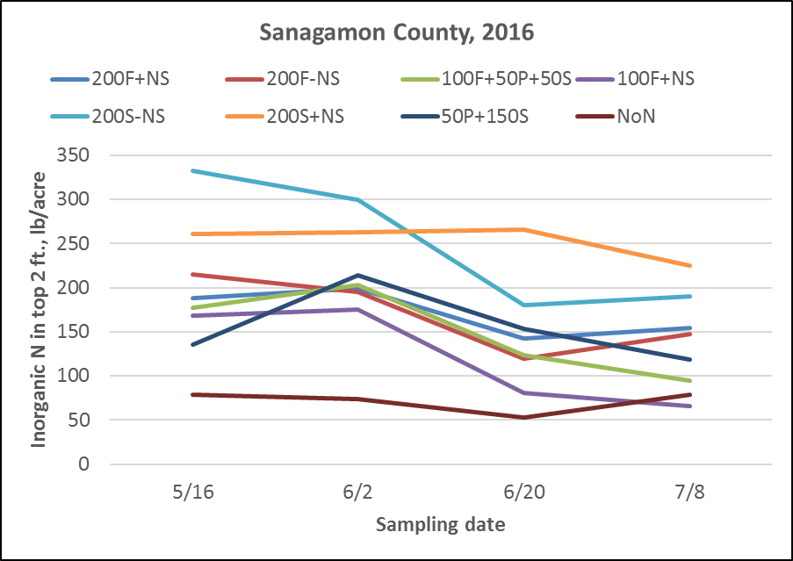

Figure 7. Soil N tracked in the on-farm location in Sangamon County, 2016.

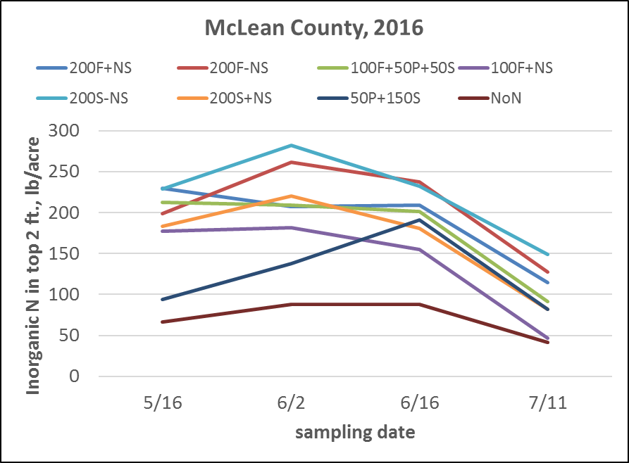

Figure 8. Soil N tracked in the on-farm location in McLean County, 2016.

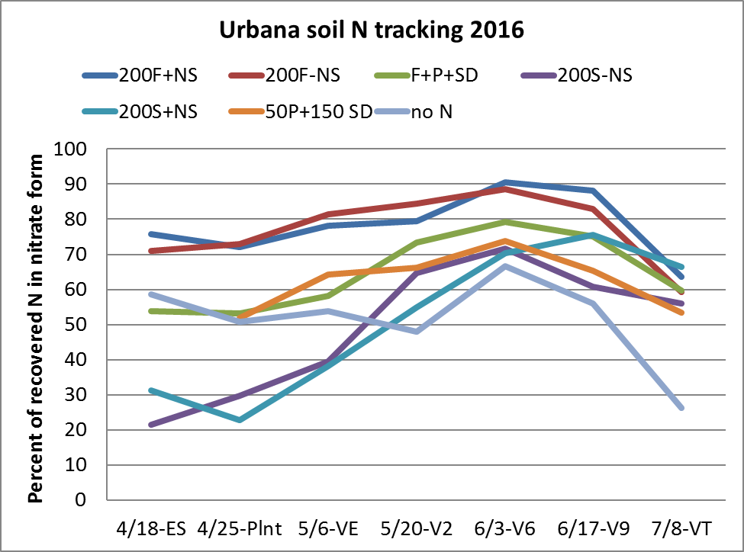

Figure 9. Percentage of soil N recovered as ammonium at Urbana, 2016.

Table 1. Corn yields with different N forms and timings in the N-tracking sites on RECS in 2016. Numbers followed by the same letters within a location aren’t significantly different at p=0.10. PT = planting time (UAN); SD = sidedress (UAN) at V5-V6.

|  |  |  |  |  |  |  |  |  |
| --- | --- | --- | --- | --- | --- | --- | --- | --- |
| Treatment | DeKalb | | Monmouth | | Urbana | | Perry | |
|  | ------------------------bushels per acre------------------------ | | | | | | | |
| Fall NH3 + N-Serve | 222 | a | 243 | a | 227 | a | 202 | a |
| Fall NH3 no N-Serve | 206 | b | 236 | a | 240 | a | 204 | a |
| Fall 100 NH3+NS + PT50+ SD50 | 219 | a | 232 | a | 239 | a | 200 | a |
| Spring NH3 + N-Serve | ---- |  | 247 | a | 239 | a | 201 | a |
| Spring NH3 no N-Serve | 218 | a | 236 | a | 238 | a | 197 | a |
| P50 UAN +Sidedress 150 UAN | 217 | a | 231 | a | 240 | a | 197 | a |
| No N | 144 | c | 185 | b | 139 | b | 175 | b |

Table 2. Corn yields with different N forms and timings in the on-farm N-tracking sites in 2015. Numbers followed by the same letters within a location aren’t significantly different.

|  |  |  |  |  |
| --- | --- | --- | --- | --- |
| Treatment | Sangamon County | | McLean County | |
|  | ----------------bushels per acre--------------- | | | |
| Fall NH3 + N-Serve | 238 | a | 273 | ab |
| Fall NH3 no N-Serve | 240 | a | 256 | c |
| Fall 100 NH3+NS + PT50+ SD50 | 221 | a | 278 | a |
| Spring NH3 + N-Serve | 252 | a | 269 | abc |
| Spring NH3 no N-Serve | 259 | a | 255 | c |
| P50 UAN +Sidedress 150 UAN | 267 | a | 261 | bc |
| No N | 161 | b | 143 | d |

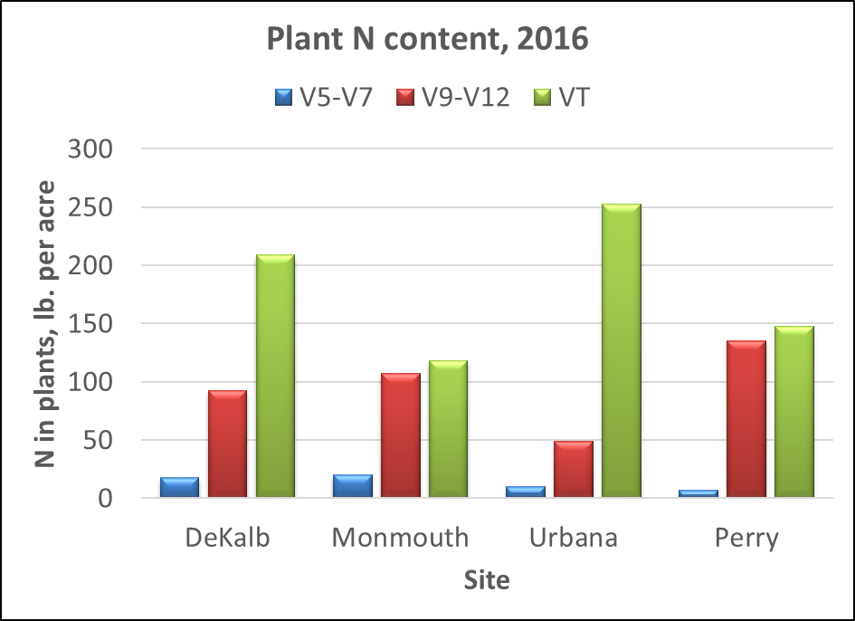

Figure 10. Plant N content at different sampling times in 2016.

**Modeling N and N management responses, 2016:**

Dr. Kamaljit Banger, Postdoctoral Research Associate, and Dr. Cameron Pittelkow

We calibrated The Decision Support Systems for Agrotechnology Transfer (DSSAT) model using soil nitrogen (N) status monitored at 10–15-day interval in 2015 and 2016 crop growing seasons. Soil ammonium and nitrate concentration at 0–30 cm and 30–60 cm across different fertilizer amount and time treatments was used in the calibration process. Soil organic matter decomposition parameters in the DSSAT model were significantly improved to obtain acceptable model predictions. To improve the model performance across soils of Illinois, we developed eight sets of model parameters based on the soil properties. The calibrated version of the model is able to predict soil N concentration (ammonium + nitrate) in response to fertilizer management (Figure 1).

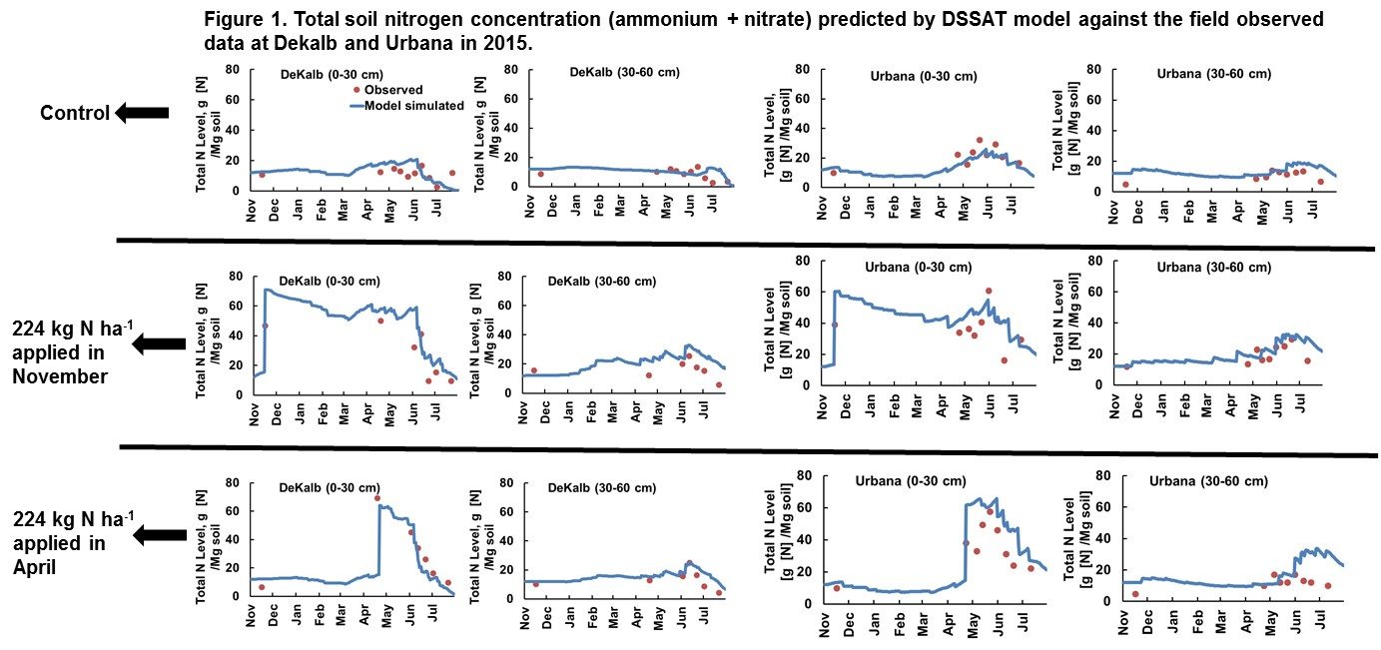

In addition, model parameters were adjusted to predict crop yield in response to N management practices in Illinois. Field data sets used for calibration and model validation included ongoing N track experiments for this project as well as previous on-farm trials and Crop Science Research and Education Center (REC) experiments. In the REC experiments, crop yields were measured for the following treatments: control, 56 kg N ha-1, 112 kg N ha-1, 168 kg N ha-1, 224 kg N ha-1, and 280 kg N ha-1. In this step, we calibrated genotype coefficients and nitrogen stress factor in the model. Improved version of the model was validated against for crop yield data from six REC experiments during 2014 and 2015 (Figure 2). To validate the model performance for predicting the impacts of fertilizer time treatments (fall vs spring, fall or spring vs split), we used the crop yield from several on-farm experiments in 2015 (Figure 3).

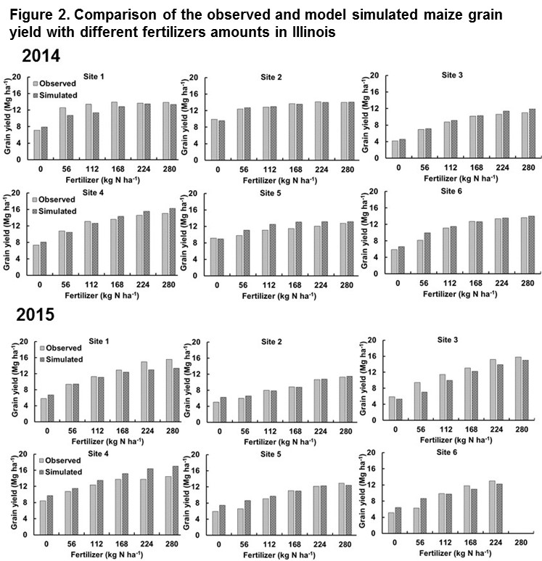

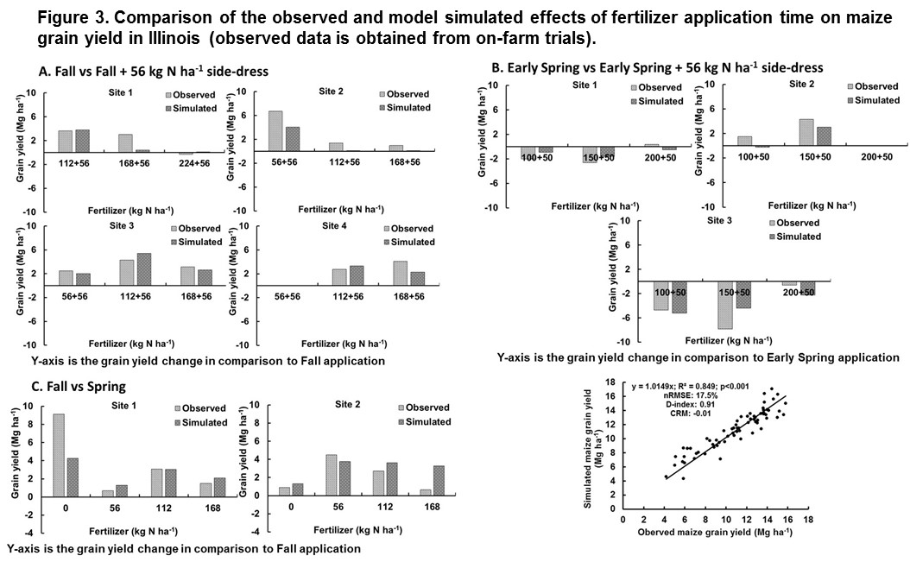

After the model calibration, we applied the DSSAT model to simulate crop yield in response to different fertilizer amounts and times on 5000 data points in Illinois during 2011–2015. To explore the impacts of nitrogen management strategies on the potential for increased economic returns while reducing environmental N losses, we interpolated the model predictions from 5000 data points to watershed scales in Illinois. The model simulations predicted that differences in crop yield for fall or spring applied N will vary depending on the cumulative amount of early season rainfall occurring in a year (Figure 4). During the study period, 2011 and 2013 had 3–9 watersheds where change in maize grain yield was highest (> 8.0% greater grain yield in spring than fall applied N), when early spring cumulative rainfall before maize planting was 18–40% greater (427–490 mm) than other years (291–349 mm).

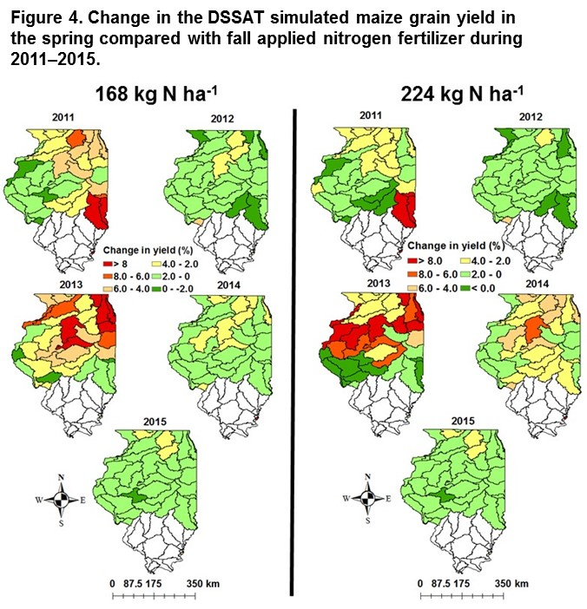

Using the model simulation data, we identified an early spring rainfall threshold of 500 mm, above which the spring applied N were predicted to produce higher crop yields. In four soil drainage classes (very poorly drained, poorly drained, somewhat poorly drained, and moderately well drained), median N use efficiency (NUE) difference in the spring and fall applied N ranged 0.1–0.5 kg grain yield/kg N with cumulative early spring rainfall of < 300 mm (Figure 5). NUE difference in the spring and fall applied N increased to 5.1 kg grain yield/kg N in very poorly drained and 1.5–3.1 kg grain yield/kg N in other soil drainage classes, when early spring rainfall is > 500 mm.

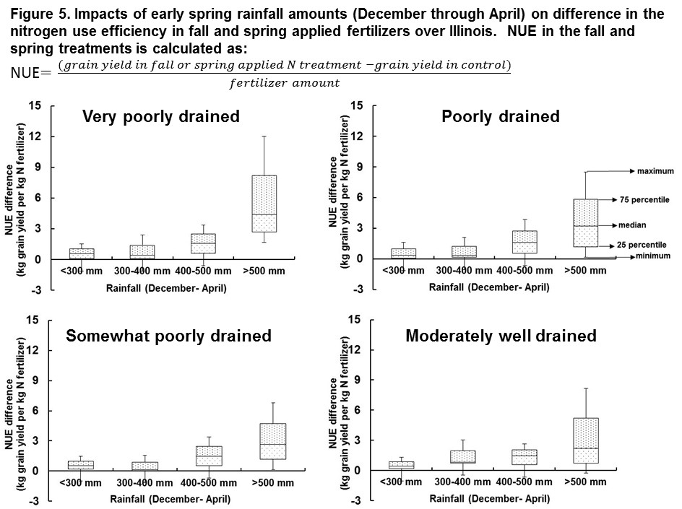

We calculated probability of positive returns for reducing fertilizer amounts to 15% by altering the application time from fall to spring in northern and central watersheds of Illinois (Figure 6). The model simulated results suggest that reduction in the fertilizer amounts from 224 kg N ha-1 to 190 kg N ha-1 had high probability of positive returns in all the northern and central Illinois watersheds since occurrence of a drought reduced crop growth. In contrast, 2014 and 2015 when crop yields were higher, had 12–16 of 40 watersheds where N management switch had high probability of positive returns. This manuscript is in preparation.

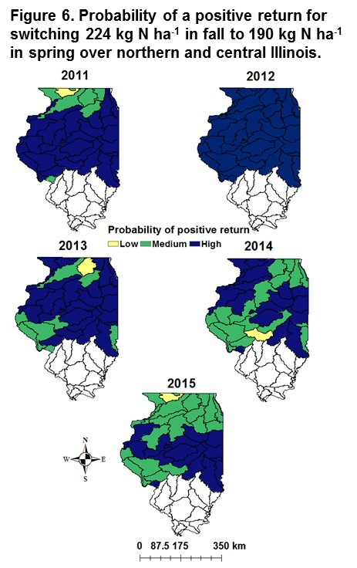

**Plans for 2017:**

Currently, we are using soil N status information from a portion of the N-Watch dataset to validate the model performance against independent field data. We are examining the amount of applied fertilizer N left as the season progresses, particularly during the period of rapid N uptake until pollination. We are also analyzing the ratio of ammonium to nitrate in the modeled vs field observed data to determine how well the model predicts nitrification dynamics.

At present, our model is validated using 2 years of field data. Once the model has been shown to produce soil N estimates with an acceptable level of accuracy, we plan to perform simulations which will allow us to answer questions about the potential for environmental N losses following different management strategies and climate conditions at watershed scales in Illinois. These exercises will result in statewide maps showing estimated soil N status (assuming a set of management scenarios), with the aim of identifying vulnerable areas for N loss due to soil and climate conditions occurring in a given year.

**Soil nitrate online tool developed in 2016**

Dr. Umar Mohammad and Dr. Junmimg Wang, Center for Atmospheric Science, Illinois State Water Survey

**Summary:**

1. A user-friendly online tool was developed for farmers and other stakeholders to estimate the real-time nitrogen availability of individual corn fields in Illinois. With this tool, users can obtain the necessary information to help them decide whether more nitrogen should be applied for optimal crop production.

2. Overall, preliminary results showed that the online tool performed reasonably well in estimating soil nitrogen availability compared with central Illinois field data.

3. Smartphone apps are being developed for a wider audience.

**Details**

The online tool tracks real-time (daily frequency) soil nitrogen availability (lbs nitrogen/acre) in cornfields for user-defined locations in Illinois. The Decision Support System for Agro-technology Transfer (DSSAT), version 4.6, is used in combination with the USDA gSSURGO soil database (soil map unit based) and daily NWS weather data (Real-Time Mesoscale Analysis, 2.5 km and 3-hour resolution downloaded to the server daily) to simulate soil nitrogen dynamics. Users are asked to provide information about the location (latitude/longitude, or click on Google Maps to choose a location), corn cultivar being used (or default), planting date and fertilizer application date(s) and amount(s), and simulation end date (default is current date). The information is sent to the server where the program prepares soil and weather files corresponding to the user’s location. DSSAT simulations are then run for the selected simulation duration, and an output is generated in the form of an e-mail to the user with times series of soil nitrogen concentrations (lbs nitrogen/acre) at depths of 0-1, 1-2, and combined 0-2 feet during the requested period from first application of nitrogen or from planting date (whichever is earliest) to the current date.

Preliminary results showed that the online tool performed reasonably well in estimating soil nitrogen availability compared with central Illinois field data. Smartphone apps are being developed for a wider audience.

